

**CZ4055 Cyber Physical System Security**

**Implementation of Correlation Power Analysis**

by: Team 5.24PM

|  |  |
| --- | --- |
| **Group Member** | **Matriculation Number** |
| Gareth Thong Jun Hong | U2021083G |
| Ryan Tan Jinn-En | U1920245A |
| Ng Jin Yang | U2020238G |

# Table of Contents

Table of Contents 2

A brief explanation of the CPA technique 4

Explanation of our CPA implementation 4

Procedure used for Plot-1: 5

Procedure used for Plot-2: 9

Experimental results and required plots: 12

Plot-1: Correlation of all possible key bytes 12

Plot-2: Correlation of the correct key byte vs number of traces 21

Literature survey on possible countermeasures against side-channel attacks: 29

Cache Timing Attacks: 29

Power-Side Channel Attack 29

Bibliography: 30

# A brief explanation of the CPA technique

The CPA technique is a side-channel attack used to extract secret information from a cryptographic device by analyzing the power consumption during its operation. This power consumption consists of power traces, which can be analyzed to detect correlation between the power consumption and the secret key, even if the key is protected by strong cryptographic algorithms.

By adopting the divide and conquer strategy, one byte of the secret key will be retrieved one byte at a time, after repeating the process 16 times, the whole secret key can be recovered. For each possible value of the key byte, build a “MODEL” trace by matching the model of every possible key byte value with the real traces. The model which matches the best with the real traces corresponds to the correct key byte.

# Explanation of our CPA implementation

To implement CPA, we wrote a program to process the power traces that we had collected during the lab session. Our program was written in Python on the Jupyter notebook platform to allow for easy visualization of our analysis. We also made use of various libraries like scipy and pandas in our code.

**Utility Functions:**

1. Hamming weight calculator:

A Hamming Weight calculator was written based on the knowledge we gained from the CPA lab session, as shown in Figure 1:

### Figure 1: Hamming Weight Calculator

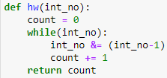

This function works by performing a bitwise AND operation of the value with the (value-1), as subtracting 1 from the value causes the rightmost bit string of 0s to become 1s, and the rightmost 1 bit to become a 0. If the value had a certain number x of bits that were 1 originally, then x iterations of the while loop would reduce the value to 0 and return the number of 1 bits in the value, which would be the Hamming Weight of the value. [1]

1. Substitution-box (Sbox) tuple:

We also included the AES Sbox tuple as shown in Figure 2, for simulating the Sbox outputs later on when building the power model:

### Figure 2: AES Sbox

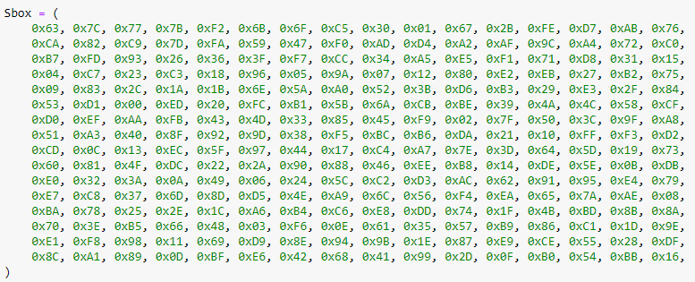

## Procedure used for Plot-1:

Firstly, we prepared our csv file of traces we had collected for further processing. These were only minor changes, with an extra row inserted at the top of our csv file to facilitate processing with pandas later on, as shown in Figure 3:

### Figure 3: CSV file of traces

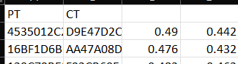

We also renamed our csv file to “anotherownwaveform.csv” to distinguish it from the “waveform.csv” sample file in the Lab-1 folder. Afterwards, we loaded our csv into our program as a pandas dataframe, as shown in Figure 4:

### Figure 4: Loading our CSV file into pandas

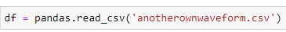

We then wrote a function to generate a power model for a user-specified byte index. The user-specified byte index ranges from 0 to 15, and is used for determining which key byte out of the 16 key bytes the power model is to be built for. This byte index will also correspond to the position of the plaintext byte to be used. The function is shown in Figure 5:

### Figure 5: powermodelgenerator() function

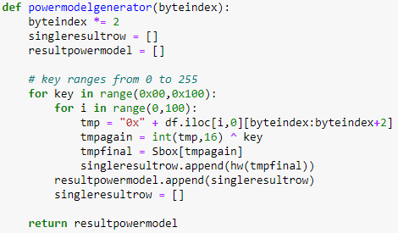

For every possible key byte from 0x00 to 0xFF, the key byte is XORed with the corresponding plaintext byte (*df.iloc[i,0][byteindex:byteindex+2]* in Figure 5*).* The output of this XORing operation is then put through the Sbox to obtain the Sbox output (*tmpfinal* in Figure 5). The hamming weight of the Sbox output is then calculated using our Hamming Weight calculator function, which is then appended to the corresponding position in our power model array. This is done for each of the 100 plaintexts in our csv file to produce a power model. Hence, the power model returned by this function is a 2D array with 256 rows and 100 columns.

Our next function is for generating a correlation matrix based on the obtained power model. This function is shown in Figure 6:

### Figure 6: correlationmatrixgenerator() function

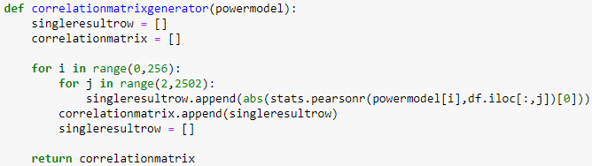

Each of the 256 rows of the power model and each of the 2500 columns of the collected power trace data is a vector of size 100, corresponding to the 100 plaintext-ciphertext pairs and respective power traces. Hence, correlationmatrixgenerator() can accept a power model as an argument and calculate the Pearson correlation coefficient between each row of the power model and each column of the power trace data. The correlation calculation is done using the pearsonr() function from the scipy.stats library as seen in *stats.pearsonr(powermodel[i],df.iloc[:,j])[0]* in Figure 6. The absolute value of the correlation coefficient is then appended into the corresponding position of the correlation matrix. The correlation matrix returned is hence a 2D array with 256 rows and 2500 columns. This correlation matrix is then processed in our next function, plotgraph(), described below.

plotgraph() is a function we wrote for plotting the graphs required for Plot-1, and accepts a correlation matrix and the index of the key byte we are trying to recover, as shown in Figure 7:

### Figure 7: plotgraph() function

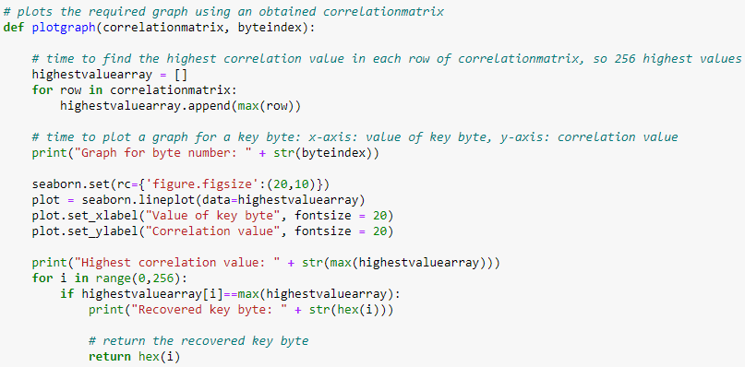

In plotgraph(), the highest correlation value in each row of the correlation matrix is first collected and appended into an array, shown in Figure 7 as *highestvaluearray*. *highestvaluearray* hence contains 256 different correlation values corresponding to the 256 different possible key byte values, in order from 0x00 to 0xFF. The highest correlation value in *highestvaluearray* therefore also corresponds to the correct value of the key byte used in the secret key bytestream.

To plot the data points in *highestvaluearray*, the lineplot() function from the seaborn library is called as seen in *seaborn.lineplot(data=highestvaluearray)* in Figure 7. The plotgraph() function also prints the highest correlation value in the plot obtained and prints and returns the corresponding key byte recovered.

Finally, all the functions we have written are put together to obtain the required graphs for Plot-1. The plot of correlation value against possible key byte values was first obtained for key byte 0:

### Figure 8a: Generating a power model for byte 0



### Figure 8b: Generating Plot-1 for byte 0

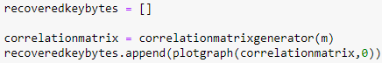

*recoveredkeybytes* in Figure 8b is simply an array for collecting the correct key bytes we have recovered.

These plots are then obtained for the remaining key bytes from 1 to 15:

### Figure 9a: Generating Plot-1 for byte 1

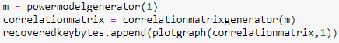

…

### Figure 9b: Generating Plot-1 for byte 15

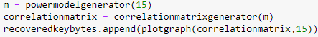

The full set of plots obtained are shown in our experimental results section. Our final recovered key is 0x4c4946454953475245415453494b4553, which corresponds to the key we had set during the lab session, as shown in Figure 10:

### Figure 10: Final recovered key

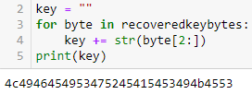

## Procedure used for Plot-2:

We made some modifications to the code used for generating Plot-1 to generate Plot-2. Firstly, we modified our powermodelgenerator() function into a secondpowermodelgenerator() function as shown in Figure 11:

### Figure 11: secondpowermodelgenerator() function

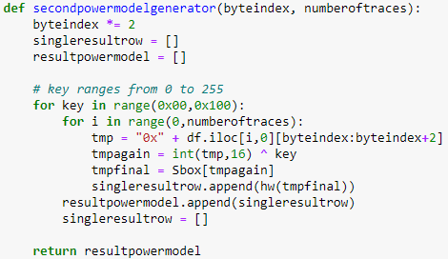

secondpowermodelgenerator() takes in the index of the key byte to be recovered and a user-defined number of traces as input. secondpowermodelgenerator() also returns a power model constructed in a similar way as powermodelgenerator(), which was used for Plot-1, with the only difference being that the power model is built on a certain number of power traces as specified in *numberoftraces* (in Figure 11) instead of the entire 100 traces. A value of 10 for *numberoftraces* means that the power model is built using only the first 10 plaintexts, while a value of 20 indicates a power model built with the first 20 plaintexts, and so on. The power model returned is hence a 2D array containing 256 rows and a number of columns equal to the number of plaintexts used.

correlationmatrixgenerator() was also modified to take in both the power model and number of traces used as input as shown in Figure 12:

### Figure 12: secondcorrelationmatrixgenerator() function

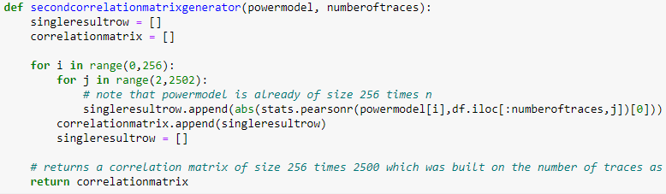

The correlation matrix is constructed in secondcorrelationmatrixgenerator() in a manner similar to correlationmatrixgenerator(), which was used for Plot-1, with the only difference being the restriction on the number of traces used when calculating the correlation coefficient, to ensure the traces correspond with the plaintexts, as seen in *stats.pearsonr(powermodel[i],df.iloc[:numberoftraces,j])[0]* in Figure 12. The correlation matrix returned still contains 256 rows and 2500 columns to accommodate all 256 possible key values and the entire length of the collected power traces.

A function secondgraphinputproducer() was written to extract and organize the information from a correlation matrix into data points suitable for plotting on a graph, for each byte, as shown in Figure 13:

### Figure 13: secondgraphinputproducer() function

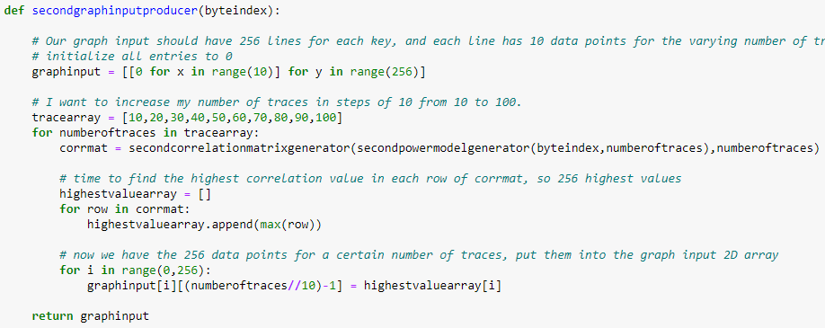

secondgraphinputproducer() also accepts the index of the key byte to be recovered as input. For a number of traces from 10 to 100, increasing in steps of 10, as defined in *tracearray* in Figure 13, a correlation matrix is generated using secondpowermodelgenerator() and secondcorrelationmatrixgenerator(). The 256 highest correlation values in each row of the correlation matrix are then extracted and stored in *highestvaluearray,* before being stored in the appropriate position in the *graphinput* matrix (Figure 13). The *graphinput* matrix returned has 256 rows and 10 columns. Each row corresponds to a possible key byte value, and each column corresponds to a number of traces in *tracearray*.

Another function secondplotgraph() was written for plotting the graphs required for Plot-2. secondplotgraph() accepts the *graphinput* matrix output from secondgraphinputproducer() in Figure 13 and the key byte index, as shown in Figure 14:

### Figure 14: secondplotgraph() function

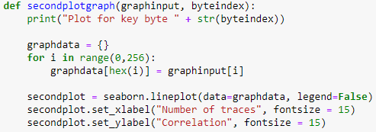

The data in the *graphinput* matrix is mapped in a dictionary and used as input to the lineplot() function from the seaborn library in Figure 14. The legend for each plot is not displayed (set to *False*) as there are 256 lines in a graph for each key byte.

All the functions written are put together to obtain the required graphs for Plot-2. The plot of correlation of the correct key byte against the number of traces was first obtained for key byte 0, as shown in Figure 15:

### Figure 15: Generating Plot-2 for key byte 0



The plots are then obtained for the remaining key bytes from 1 to 15, as shown in Figures 16a and 16b:

### Figure 16a: Generating Plot-2 for key byte 1

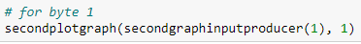

…

### Figure 16b: Generating Plot-2 for key byte 15

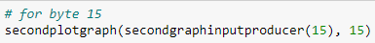

The full set of plots obtained are shown in our experimental results section.

# Experimental results and required plots

## Plot-1: Correlation of all possible key bytes

For Plot-1, the x-axis is the value of the key byte ranging from 0x00 to 0xFF, while the y-axis is the correlation value. For each plot, the highest peak (circled in red) represents the highest correlation value corresponding to the correct key byte for that particular byte. There are a total of 16 plots for all 16 bytes of the key.

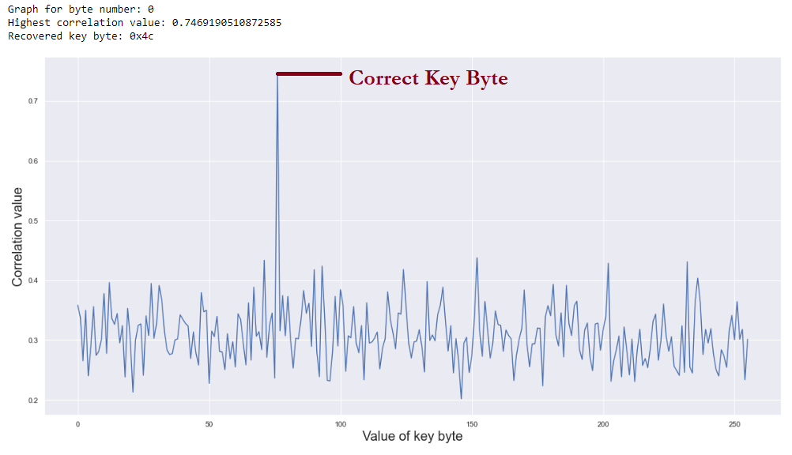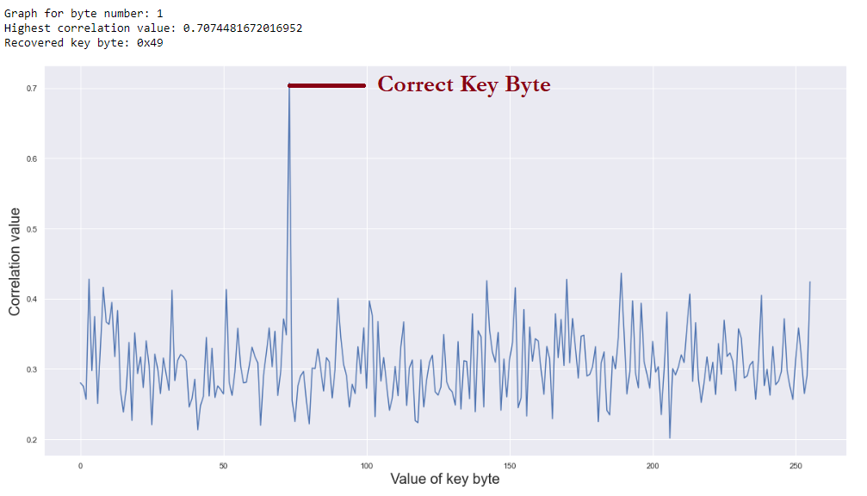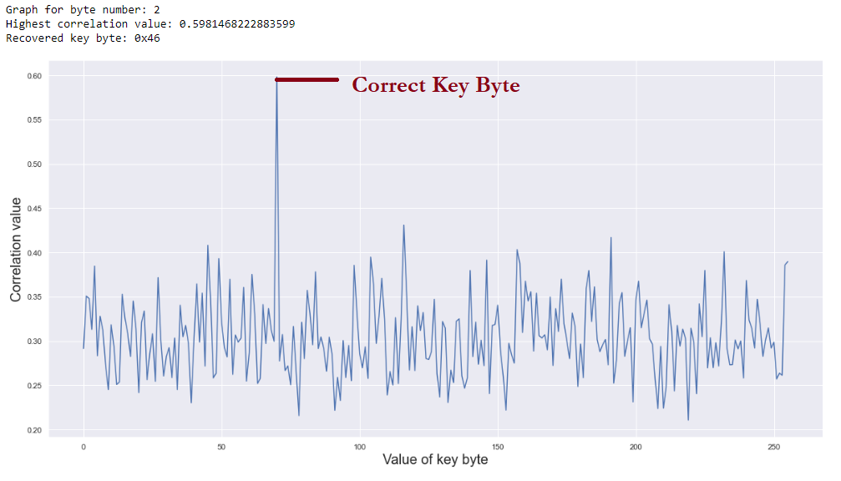

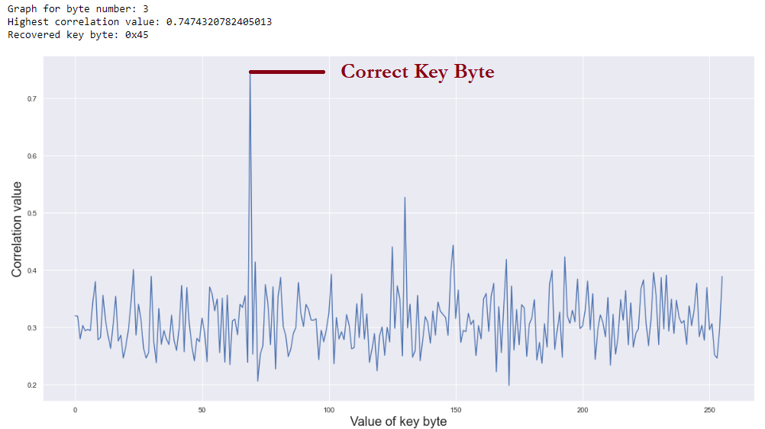

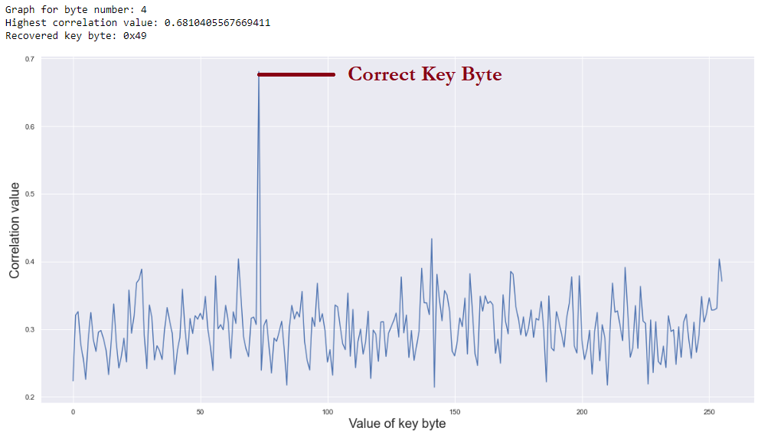

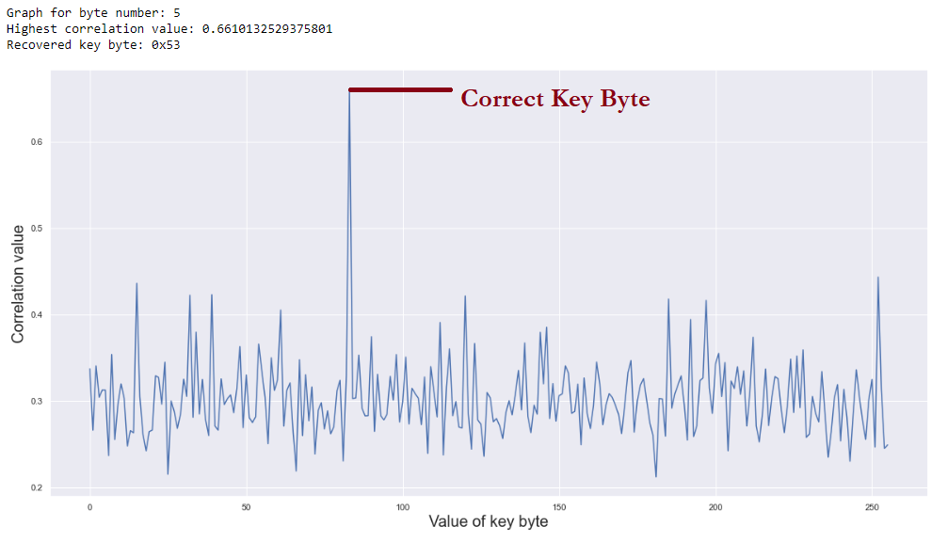

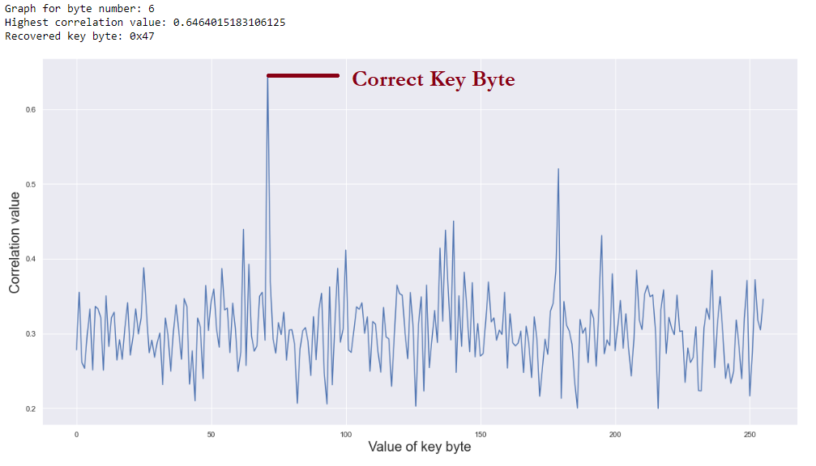

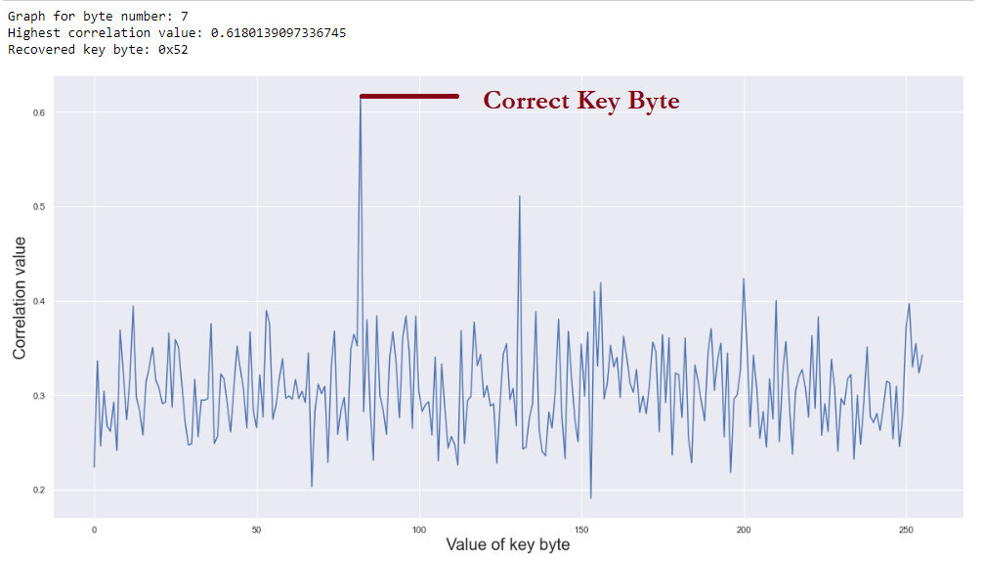

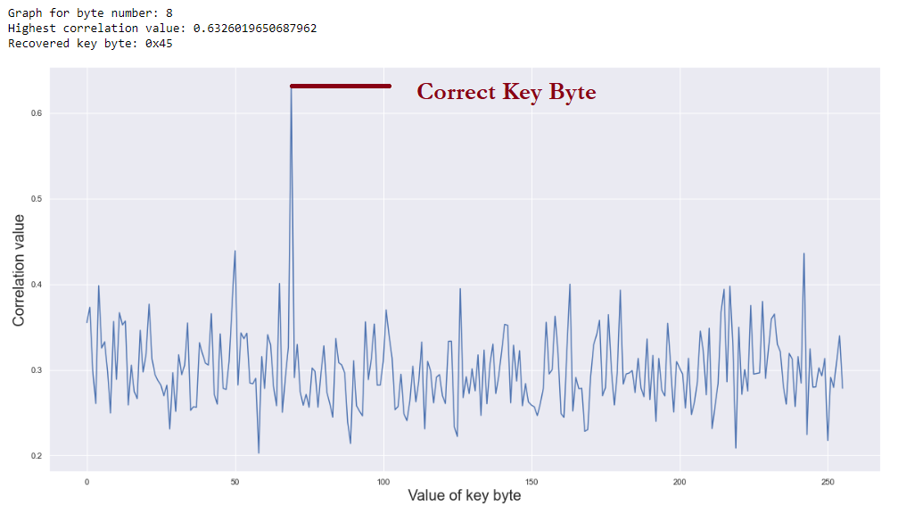

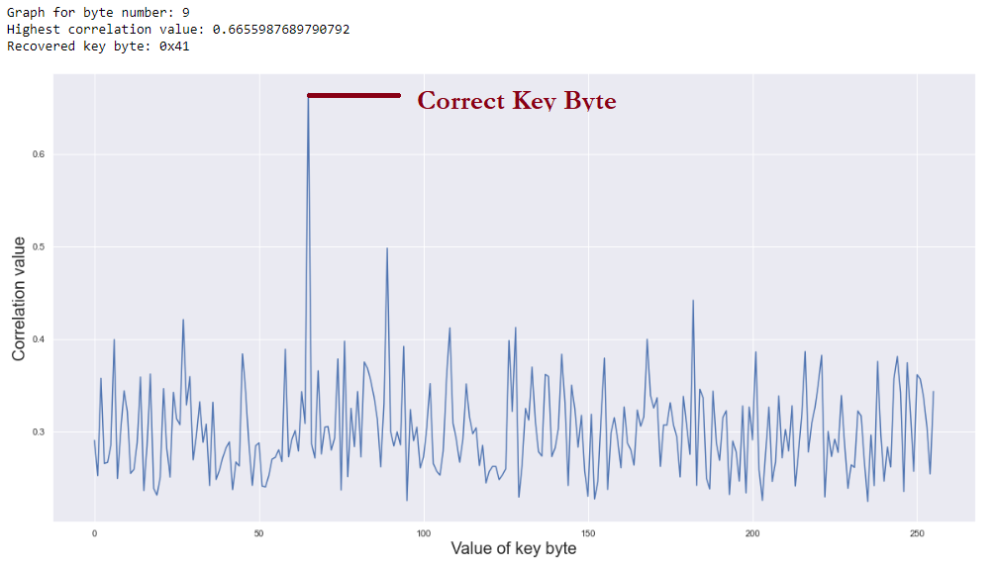

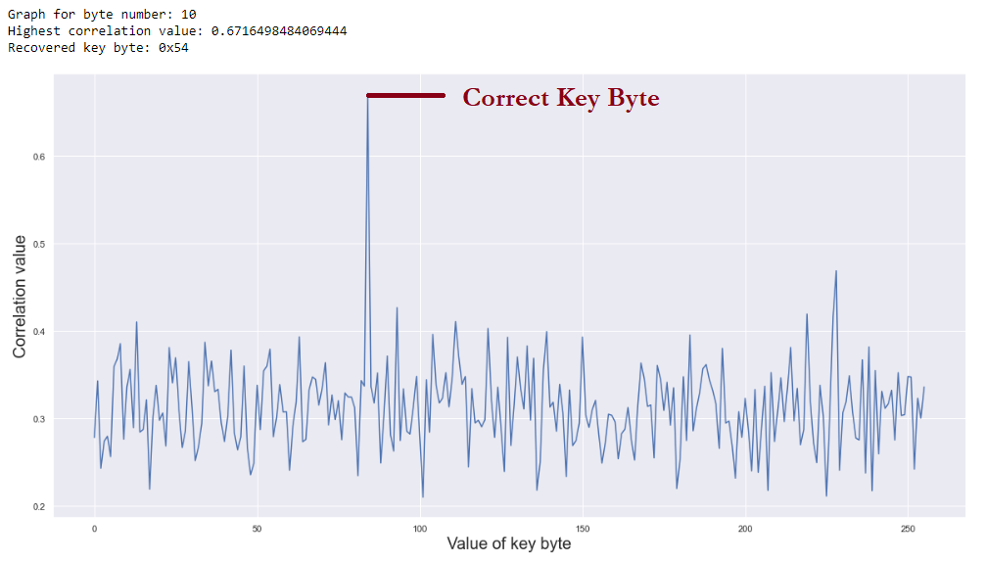

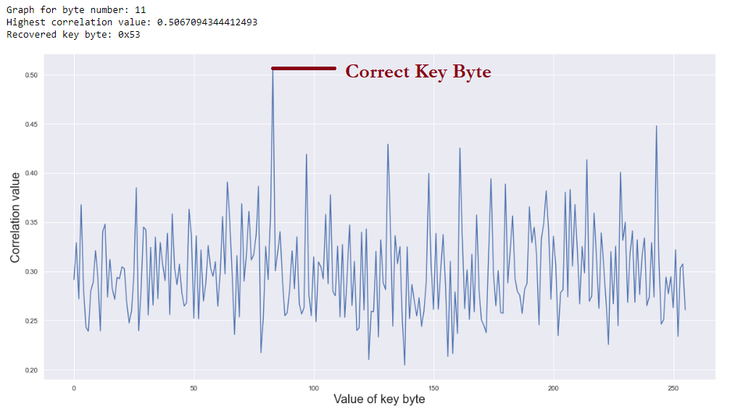

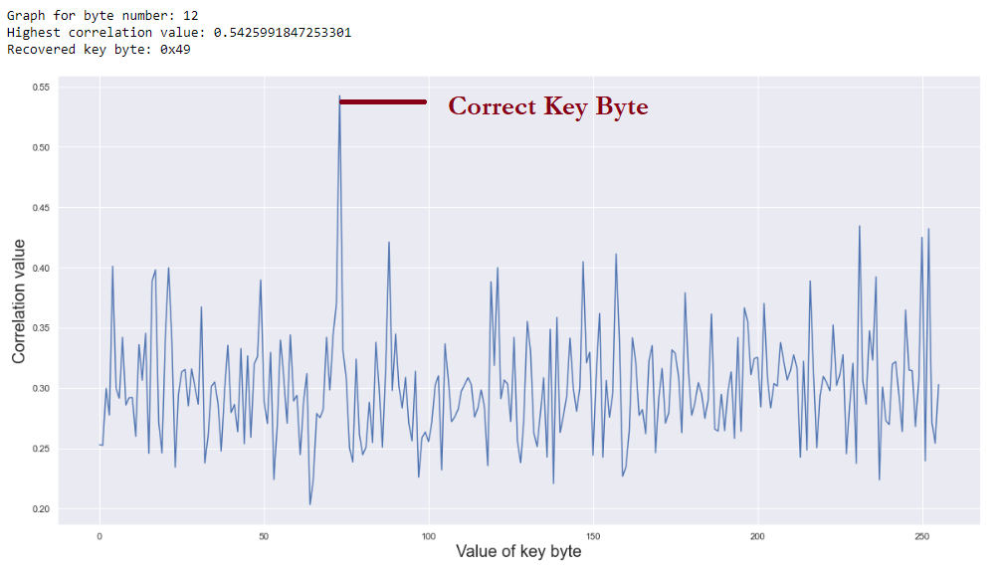

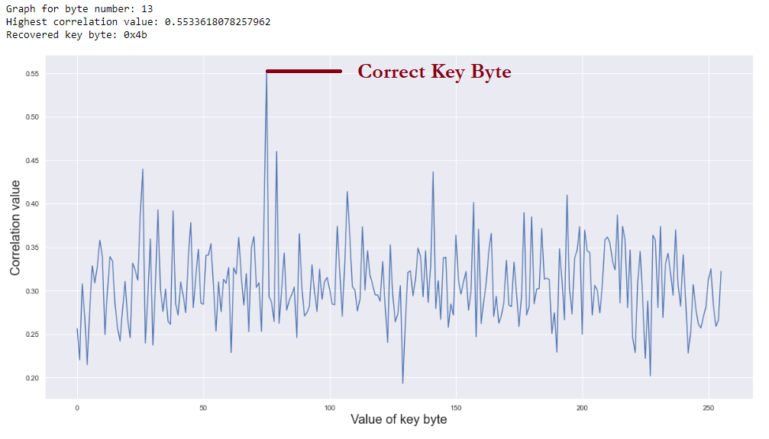

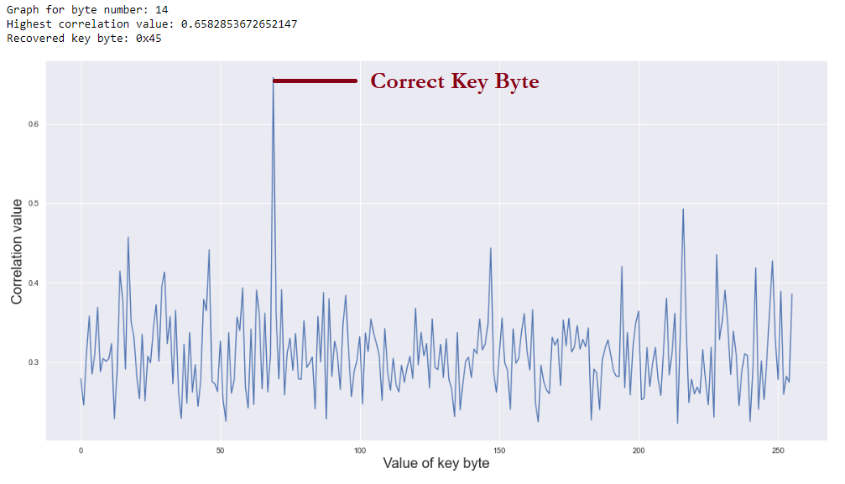

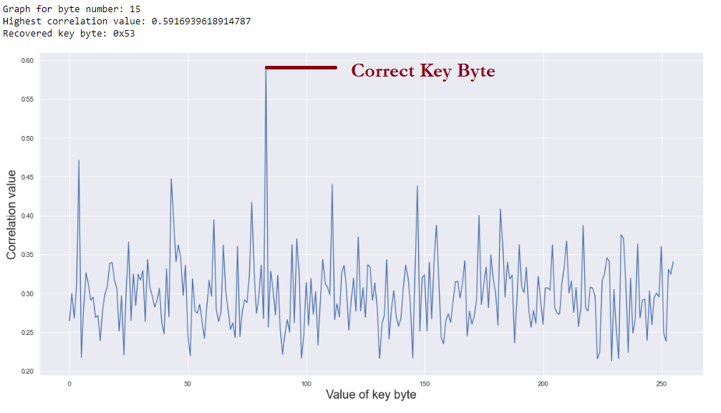

## Plot-2: Correlation of the correct key byte vs number of traces

For Plot-2, the x-axis is the number of traces used for CPA, while the y-axis is the respective correlation value of the 256 possible key byte values. The legend for each plot was omitted due to space limitations, but it can be seen that the correct key byte value emerges as the green plot and separates from the rest of the plots as the number of traces increases. There are 16 plots for all 16 bytes of the key.

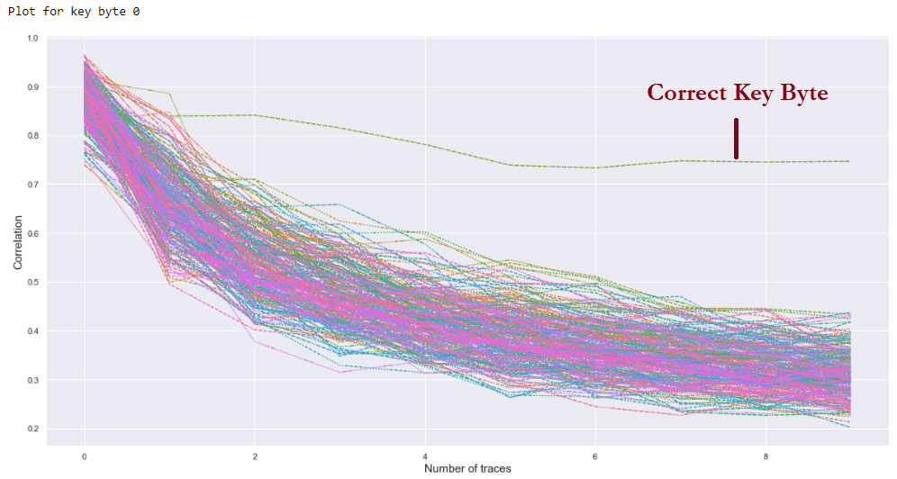

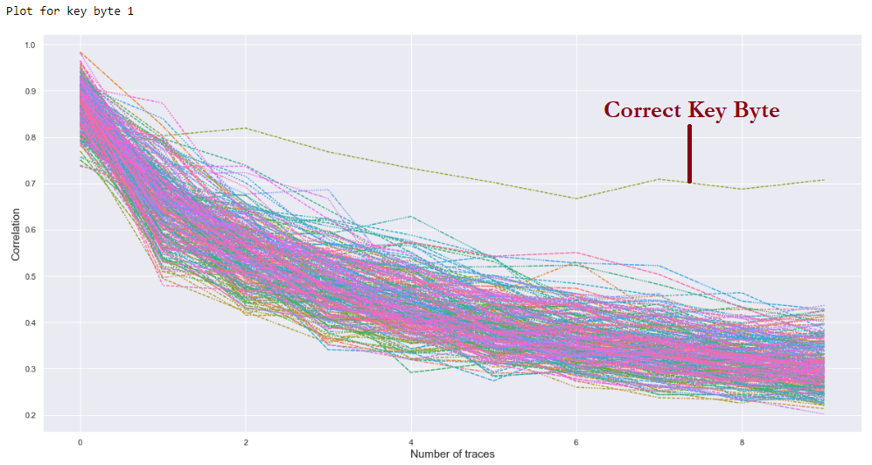

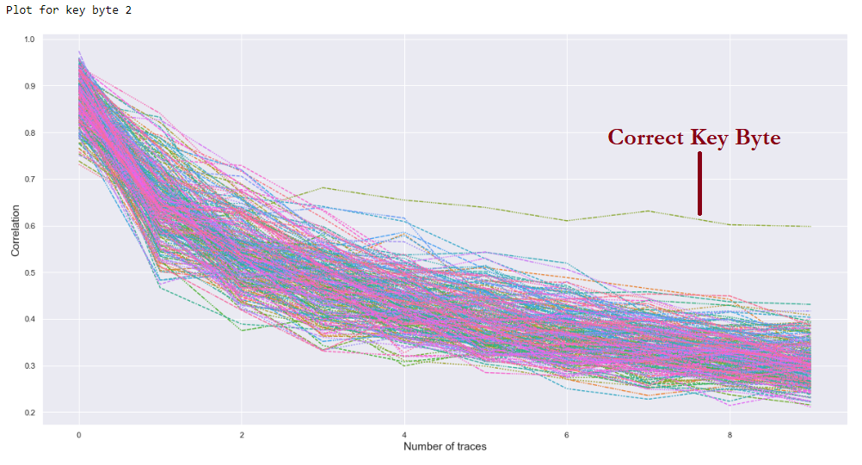

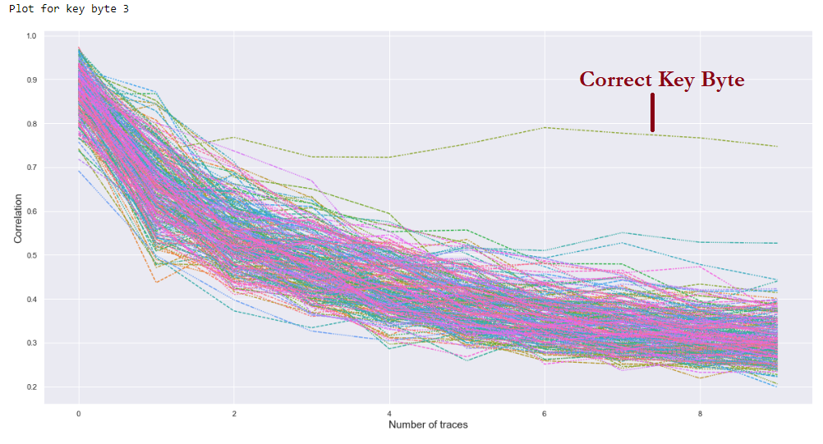

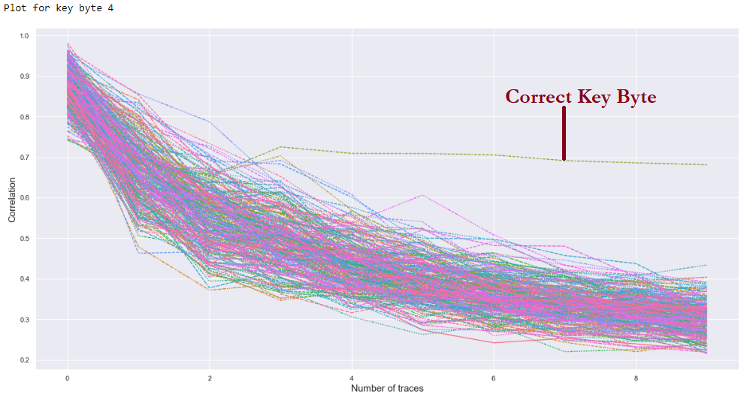

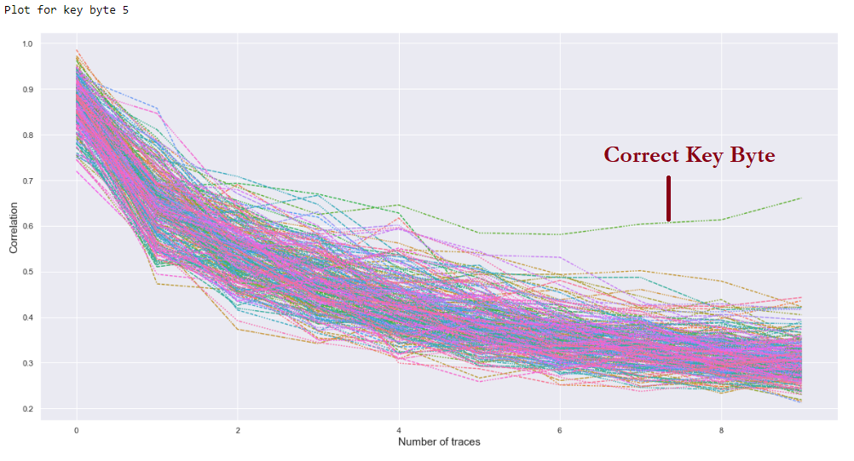

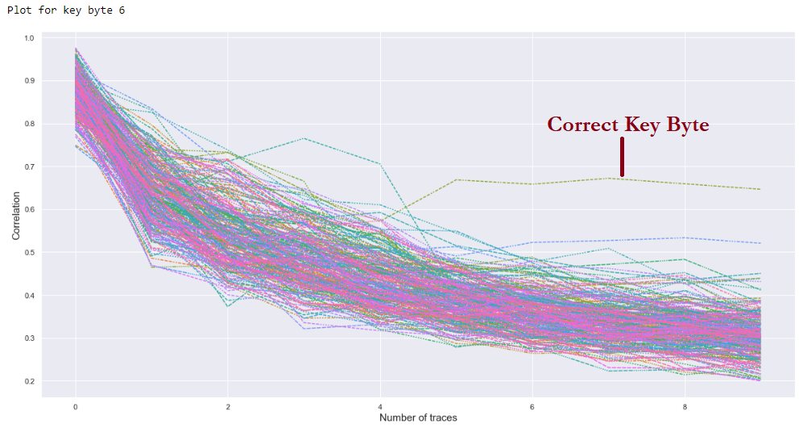

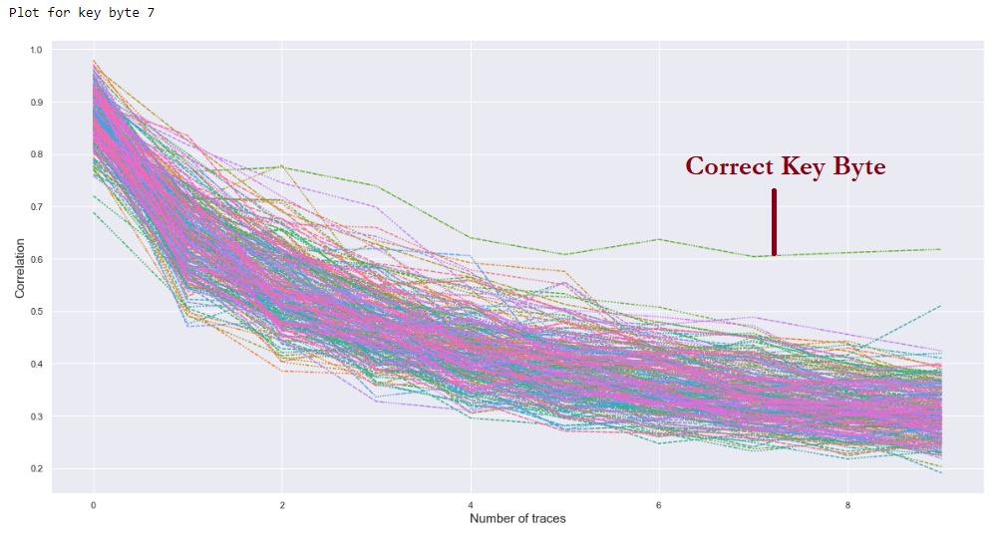

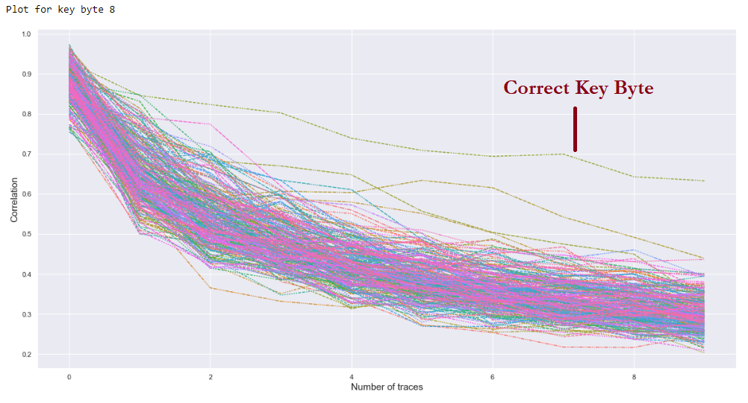

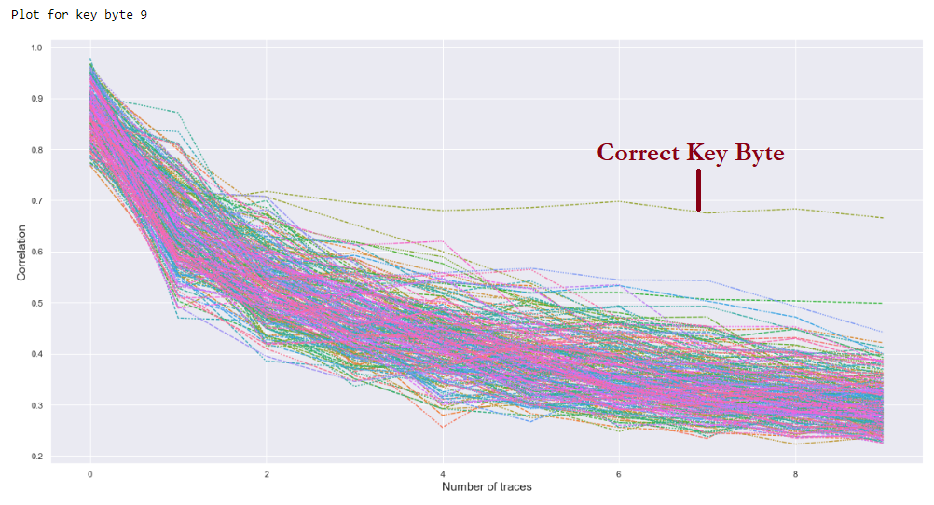

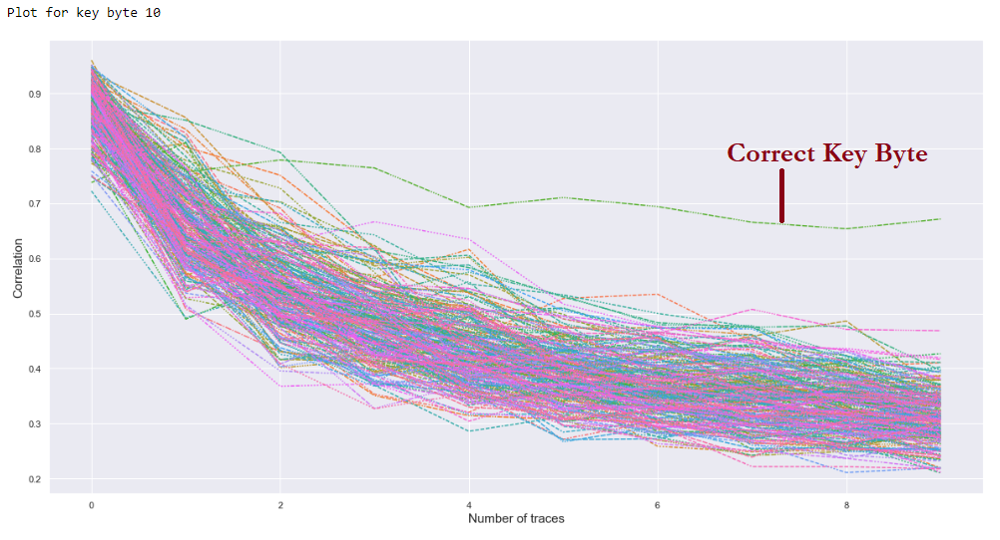

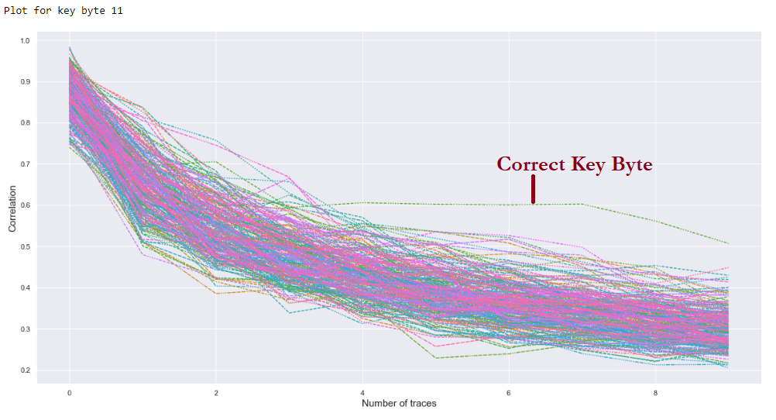

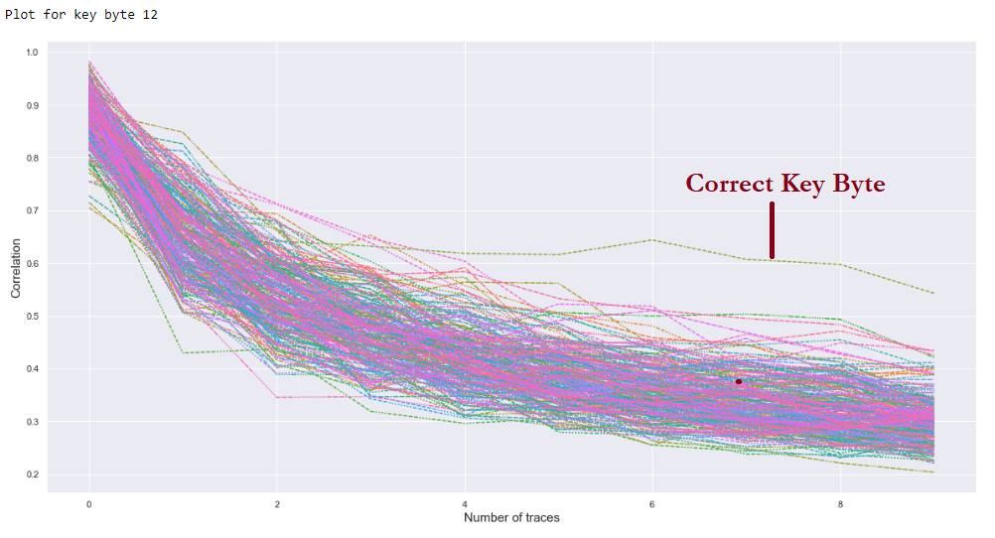

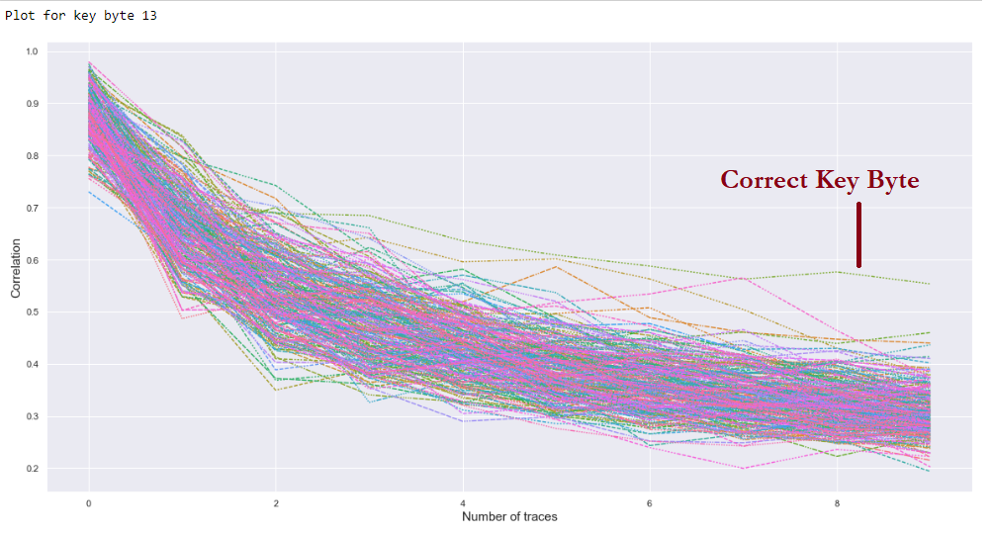

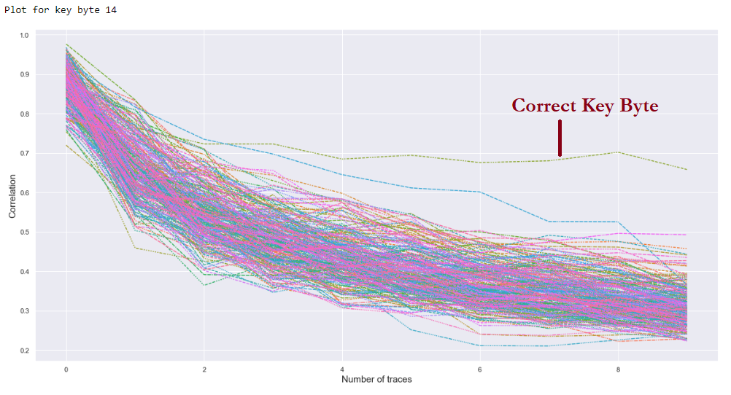

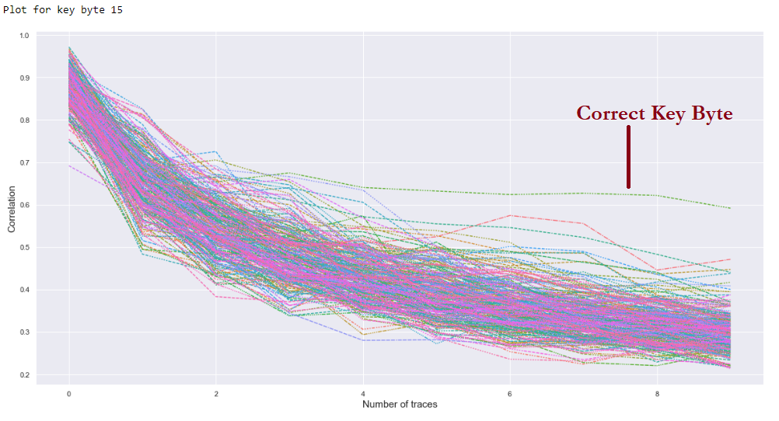

# Literature survey on possible countermeasures against side-channel attacks

## Cache Timing Attacks:

Clock jitter **-** A 'for' loop is included to execute 'NOP' instructions, where it executes from zero to a random or specified number as a means of introducing noise meant to counteract an attacker’s ability to obtain an accurate cache-time reading.

Examples include using a random number between 0 and 20 was generated and a ‘for loop’ was run from zero to the generated number. Alternatively, a secret number that is then subjected to several “black-box” formulae that in turn determines the number of ‘for’ loops carried out after each iteration can be used in place to reduce the additional computational overhead. When subsequently performing the attack, it can be observed that some of the key bytes are missing due to incorrect timing information received from the server, resulting in the attacker being unable to correctly identify the actual timing pattern. [2]

Despite random ‘for’ loops being a successful side-channel countermeasure, generating a random number consumes a large number of CPU clock cycles, consequently increasing the computational overhead of the AES encryption.

## Power-Side Channel Attack

Dummy insertion **-** Random insertion of dummy operations scheme is a technique that randomly inserts dummy operations which are irrelevant to encryption and decryption into the middle of the real operations, making it difficult for attackers to identify when the actual target operations are being executed. When applying the hidden schemes to the cryptographic algorithm mixing both dummy operations and the shuffling scheme, the same array must be involved in both the dummy and real operations. Additionally, the shuffling scheme should be applied to the order of storing the operation target values rather than the order of operations, so as to minimize distinguishability while increasing the intended attack complexity.

Despite the implementation, real and dummy operations can still be distinguished for different dummy operation implementations, which are mainly used by hiding schemes as countermeasures against SCA. Countermeasures implemented using C language implement four types of variables that can be used in dummy operations, namely local variables, global variables, separate function arguments, and combined function arguments. In all four cases dummy operations can still be distinguished from real ones based on the power consumption traces, indicating that such schemes may not entirely ensure intended attack complexity. [3]

# Bibliography

[1] P. Wegner, “A technique for counting ones in a binary computer,” Communications of the ACM, vol. 3, no. 5, p.322, May 1960.

[2] Alawatugoda, J., Jayasinghe, D., & Ragel, R. (2011, August). Countermeasures against Bernstein's remote cache timing attack. In Industrial and Information Systems (ICIIS), 2011 6th IEEE International Conference on (pp. 43-48). IEEE.

[3] D.-G. H. JongHyeok Lee, “Security analysis on dummy based side-channel countermeasures—Case study: AES with dummy and shuffling,” Applied Soft Computing, vol. 93, no. 1568-4946, August 2020.